**A REPORT ON**

**OBJECT RECOGNITION SYSTEM**

Submitted By

**Vrushali Birendra Chaube**

**Swathi Illuru**

**Akhil Jayanthi**

**Harsha Kota**

Under The Guidance of

**Mr. Anil Kumar Shaw**

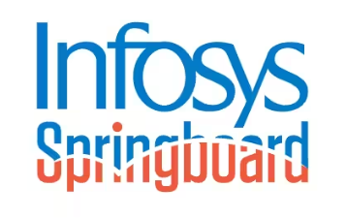

**Infosys SpringBoard Internship 5.0**

**INDEX**

**1 INTRODUCTION 1**

1.1 Overview of the Project…...……………………………….……………...1

1.2 Objectives...………………………………………………….....................1

1.3 Scope of Work……………………………………………….....................2

**2 ACKNOWLEDGEMENT 4**

**3 ABSTRACT 5**

**4 PROJECT CONTEXT 6**

4.1 Challenges and Solution………………………...………………………..6

4.2 Use Cases ………………………………………………………………..7

**5 TECHNICAL DETAILS**

5.1 Dataset Description

5.2 Evaluation Metrics

5.3 Preprocessing Steps

**6 FASTER RCNN MODEL**

6.1 Introduction

6.2 Methodology

6.3 Results

6.4 Drawbacks

6.5 Issues Encountered

6.6 Output

**7 MASKED RCNN MODEL**

7.1 Introduction

7.2 Methodology

7.3 Results

7.4 Drawbacks

7.5 Issues Encountered

7.6 Output

**8 YOLOv5 MODEL**

**9 IMPLEMENTATION IN VS CODE**

9.1 Image Detection Pipeline

9.2 Video Detection Pipeline

9.3 Webcam Detection Pipeline

**10 RESULT AND ANALYSIS**

10.1 Model Performance Metrics

10.2 Visual Examples of Output

**11 FUTURE DIRECTIONS**

11.1 Model Optimization

11.2 Deployment Plans

11.3 Advanced Feature

**12 CONCLUSION**

**13 APPENDIX**

13.1 Code Snippets

13.2 sample Outputs

**14 REFERENCES**

**CHAPTER 1 : INTRODUCTION**

* 1. **Overview of the Project:**

The Object Recognition System focuses on the automated detection, classification, and segmentation of objects in images and videos. Object recognition is a critical component in many industries, such as healthcare, autonomous vehicles, retail, and security. To address diverse object recognition requirements, the system integrates three state-of-the-art deep learning models Mask R-CNN, Faster R-CNN, and YOLOv5 chosen for their unique strengths:

* Mask R-CNN: This model performs pixel-level segmentation, which allows for identifying the exact shape and boundary of objects within an image. It is particularly useful in scenarios where detailed information about object boundaries is crucial, such as medical imaging, where accurate tumor or organ segmentation is needed. Mask R-CNN excels in tasks that require precision over speed.
* Faster R-CNN: Faster R-CNN combines Region Proposal Networks (RPN) with object classification and bounding box regression, offering high detection accuracy. It is widely used in tasks where accuracy is a priority, such as identifying objects in static images or analyzing pre-recorded videos. Faster R-CNN is a robust choice for general-purpose object detection tasks.
* YOLOv5: Unlike the above models, YOLOv5 prioritizes real-time detection and efficiency. It processes images and videos at high speed while maintaining respectable accuracy. This makes it suitable for applications like real-time surveillance, autonomous vehicles, and drone-based monitoring, where quick decision-making is vital.
  1. **Objectives:**

The primary objective of this project is to develop a robust object recognition system capable of detecting, classifying, and segmenting objects in images and videos with high accuracy and speed. To achieve this, the system integrates three advanced deep learning models Mask R-CNN, Faster R-CNN, and YOLOv5 and evaluates their performance on standard datasets to understand their strengths and weaknesses in terms of speed, accuracy, and computational requirements. The project is designed to offer flexibility, enabling users to choose the most suitable model based on specific application needs. For example, YOLOv5 is ideal for real-time applications like video surveillance due to its speed, Mask R-CNN is preferred for tasks requiring pixel-level accuracy such as medical imaging, and Faster R-CNN is suited for general-purpose object detection with high accuracy.

Additionally, the system is intended for deployment across various industries, including healthcare for detecting tumors or fractures, security for identifying intruders or unauthorized vehicles, retail for automating checkout systems or monitoring stock levels, and autonomous vehicles for recognizing pedestrians, vehicles, and road signs. Future scalability is a key focus, with plans to support real-time deployment on edge devices, incorporate more advanced models for enhanced performance, and extend the application to other domains such as agriculture and industrial automation. By addressing these objectives, the project aims to create a comprehensive, efficient, and adaptable object recognition system that meets the needs of diverse real-world applications.

* 1. **Scope of Work:**

The Object Recognition System developed in this project is designed to automate the detection, classification, and segmentation of objects in images and videos, addressing critical needs across industries such as healthcare, autonomous vehicles, retail, and security. To meet diverse object recognition requirements, the system integrates three advanced deep learning models—Mask R-CNN, Faster R-CNN, and YOLOv5—each selected for its unique strengths. Mask R-CNN excels in pixel-level segmentation, making it ideal for applications requiring detailed object boundaries, such as tumor or organ segmentation in medical imaging. Faster R-CNN offers high detection accuracy by combining Region Proposal Networks (RPN) with object classification and bounding box regression, making it suitable for general-purpose object detection tasks. YOLOv5, on the other hand, prioritizes real-time detection with high efficiency, making it an excellent choice for applications like surveillance, autonomous driving, and drone monitoring. The integration of these models ensures that the system is both flexible and scalable, allowing users to choose the most appropriate model based on their specific needs. The system has been tested and validated on diverse datasets to handle real-world challenges such as varying lighting conditions, background clutter, and overlapping objects.

The system is designed to offer flexibility, enabling users to select models based on specific requirements, such as YOLOv5 for real-time applications, Mask R-CNN for precision-oriented tasks, and Faster R-CNN for high-accuracy detection. Furthermore, the project aims for real-world deployment across various industries, including healthcare for detecting anomalies in medical images, security for identifying intruders in surveillance feeds, retail for automating stock monitoring, and autonomous vehicles for object recognition on roads. Future scalability has also been considered, with plans to extend the system's capabilities to other domains like agriculture and industrial automation, while exploring real-time deployment on edge devices such as NVIDIA Jetson Nano and Google Coral.

The scope of work for this project involves multiple stages, starting with the development and integration of the three models. Mask R-CNN, Faster R-CNN, and YOLOv5 are implemented and trained on standard datasets like COCO and Pascal VOC to ensure broad applicability. Data preprocessing steps, including resizing, normalization, and augmentation, are applied to enhance model performance. Performance evaluation is conducted using metrics such as Mean Average Precision (MAP), Intersection over Union (IoU), inference speed, and F1 Score, allowing for a comprehensive comparison of the models. A user-friendly interface is developed to enable non-technical users to operate the system, providing features to select models and view results, such as bounding boxes and segmentation masks. Real-world testing is conducted on custom datasets and real-time video feeds to assess practical utility. Future development includes exploring edge device deployment for low-power applications and extending the system's use cases to domains such as detecting pests in agriculture and identifying product defects in industrial automation.

**CHAPTER 2 :** **ACKNOWLEDGEMENT**

I, Vrushali Birendra Chaube, would like to express my sincere gratitude to my mentor, Mr. Anil Shaw, for their invaluable guidance, unwavering support, and continuous encouragement throughout the duration of this project. Their expertise and insightful advice in the field of [relevant field, e.g., computer vision, deep learning] have played a pivotal role in shaping the approach, methodology, and successful execution of this work.

I am particularly thankful for their patience, constructive feedback, and willingness to share their knowledge, which have significantly enriched my understanding and skills in the domain of object recognition. Their mentorship has been a source of inspiration, motivating me to approach challenges with determination and a problem-solving mindset.

I would also like to extend my heartfelt thanks to my family, friends, and colleagues for their unwavering support and understanding throughout this journey. Their encouragement has provided me with the strength and motivation to stay focused and achieve my goals.

Finally, I am deeply appreciative of everyone who has directly or indirectly contributed to the successful completion of this project. Your guidance, support, and kindness have been instrumental in making this endeavor a meaningful and rewarding experience.

**CHAPTER 3 :** **ABSTRACT**

In this project, we present an innovative approach to real-time object detection and recognition by utilizing cutting-edge deep learning models. Our methodology encompasses a well-structured workflow that includes data collection, preprocessing, model training, and deployment, ensuring a seamless and efficient object detection pipeline.

To begin, a diverse and representative dataset was curated, encompassing various object categories to ensure robust model training. Data augmentation techniques, such as flipping, rotation, scaling, and color transformations, were applied to improve the generalization capabilities of the models and handle variations in lighting, orientation, and background clutter. This step was crucial in creating a robust system capable of performing well under diverse real-world conditions.

For model training, we employed advanced object detection frameworks, including RCNN, Faster RCNN, Mask RCNN, YOLOv5, and YOLOv8. Each model was carefully chosen for its unique strengths: RCNN and Faster RCNN for high-accuracy detection, Mask RCNN for pixel-level segmentation, and YOLOv5 and YOLOv8 for their real-time detection capabilities. YOLOv8, in particular, was selected for its lightweight architecture, enabling deployment on resource-constrained devices without compromising speed or accuracy.

The training process utilized publicly available datasets such as COCO, enabling the models to learn object features effectively. Evaluation metrics, including Mean Average Precision (MAP), Intersection over Union (IoU), and inference speed, were used to assess model performance. The models were fine-tuned iteratively to optimize their detection accuracy and speed.

To facilitate efficient deployment, the trained models were serialized into pickle files, allowing for easy storage and reuse. This approach reduces the computational overhead of re-training and ensures quick access during real-time operations. For the deployment phase, we developed a user-friendly interface using Flask, a lightweight web framework, to provide an intuitive platform for interacting with the object detection system.

Real-time testing was achieved by integrating the system with a live camera feed. This connection enabled instant object recognition, providing users with immediate feedback on detected objects along with their bounding boxes and classifications. The YOLOv8 model, optimized for superior inference speed and computational efficiency, played a pivotal role in ensuring smooth real-time performance even on devices with limited processing power, such as edge devices or embedded systems.

This work showcases the practicality of deploying advanced object detection systems in real-world applications, such as surveillance, healthcare, retail, and autonomous vehicles. By balancing computational efficiency and predictive accuracy, the system demonstrates the feasibility of leveraging deep learning models for real-time object detection.

**CHAPTER 4 : PROJECT CONTEXT**

**4.1 Challenges and Solution:**

Developing an object detection system for real-time applications comes with numerous technical and practical challenges. Below, we discuss these challenges and the solutions devised to address them:

**1. Challenge: Data Diversity and Generalization**

* Issue: A critical requirement for any object detection system is the ability to generalize well across different scenarios, such as varying lighting conditions, object orientations, occlusions, and cluttered backgrounds.
* Solution: To address this, we curated a diverse dataset from publicly available repositories like COCO. Data augmentation techniques, including flipping, rotation, scaling, and brightness adjustments, were applied to enhance the dataset's diversity and ensure that the models perform well in varied real-world conditions.

**2. Challenge: Real-Time Performance**

* Issue: Real-time object detection requires models to operate with high inference speed while maintaining accuracy, especially for resource-constrained devices.
* Solution: YOLOv8, a lightweight and efficient model, was integrated into the system. Its architecture is optimized for high-speed inference, making it suitable for real-time applications. Additionally, the system was fine-tuned to reduce latency without compromising prediction quality.

**3. Challenge: Balancing Accuracy and Speed**

* Issue: Some applications prioritize accuracy (e.g., medical imaging), while others demand speed (e.g., video surveillance). Meeting both requirements in a single system is challenging.
* Solution: The project incorporated multiple models (Mask RCNN, Faster RCNN, YOLOv5) to cater to specific use cases. Users can select the model most appropriate for their needs—YOLOv8 for speed-critical tasks and Mask RCNN for high-accuracy requirements.

**4. Challenge: System Deployment**

* Issue: Deploying object detection models locally and ensuring compatibility with different hardware configurations, including edge devices, can be complex.
* Solution: Models were serialized into pickle files for efficient reuse, and Flask was used to create a lightweight, user-friendly interface. This deployment approach ensures compatibility with a range of devices, from high-performance servers to low-power edge devices.

**5. Challenge: Real-Time Integration**

* Issue: Integrating the system with live camera feeds for real-time testing requires low latency and high reliability.
* Solution: The system was designed to process video frames in real-time, delivering quick and accurate predictions. Efficient algorithms and hardware acceleration options were utilized to reduce processing time.

**6. Challenge: Model Evaluation and Comparison**

* Issue: Determining the strengths and weaknesses of different models in varying scenarios is essential but requires rigorous testing and evaluation.
* Solution: Standard evaluation metrics such as Mean Average Precision (MAP), Intersection over Union (IoU), and F1 Score were used to measure performance. Comparative analysis was performed on speed, accuracy, and computational requirements, enabling informed decision-making for specific use cases.

**4.2 Use Cases:**

The object detection system developed in this project is versatile and can be applied across a wide range of industries and domains. Below are some of the most prominent use cases:



**1. Healthcare:** Detect tumors in medical scans, ensuring early diagnosis and better treatment outcomes.

**2. Safety and Surveillance:** Identify unauthorized access or hazardous objects, improving public safety and emergency response.

**3. Logistics and Warehouse Automation:** Automate package sorting and inventory tracking, reducing errors and speeding up operations.

**4. Retail:** Monitor shelves for restocking needs, enhancing customer experience and minimizing stockouts.

**5. Automotive:** Enable pedestrian and obstacle detection, enhancing the safety of autonomous and driver-assisted vehicles.

**6. Manufacturing:** Perform real-time quality checks on assembly lines, improving product quality and reducing defects.

**CHAPTER 5 : TECHNICAL DETAILS**

**5.1 Dataset Description:**

For this project, a subset of 5,000 images from the COCO (Common Objects in Context) dataset was utilized. The COCO dataset is a widely recognized and extensively used benchmark in the field of computer vision, specifically designed for tasks such as object detection, segmentation, and image captioning. It contains a diverse range of images with objects in natural and cluttered scenes, making it an ideal choice for training robust deep learning models.

The selected subset includes images annotated with bounding boxes, segmentation masks, and class labels across 80 object categories such as "person," "car," "dog," and "chair." These annotations enable precise training for object detection and segmentation tasks. The images in the COCO dataset are highly varied, covering different lighting conditions, perspectives, and levels of object occlusion, ensuring that the trained models can generalize well to real-world scenarios.

To prepare the data for training, preprocessing techniques such as image resizing, normalization, and augmentation were applied. Augmentation included operations like flipping, rotation, and brightness adjustments to enhance model generalization. The dataset was divided into three parts: 70% for training, 20% for validation, and 10% for testing, ensuring a balanced evaluation process.

By leveraging 5,000 images from this comprehensive dataset, the project achieves a balance between computational efficiency and model performance, while retaining the diversity and complexity needed for robust object detection in real-world applications.

**5.2 Evaluation Metrics:**

The evaluation of the object detection models in this project was conducted using industry-standard metrics to assess their performance across different dimensions, such as accuracy, speed, and computational efficiency. The following metrics were used:

**1.Precision and Recall:**

* Precision measures the proportion of correctly identified objects out of all predicted objects. It reflects the model's ability to avoid false positives.

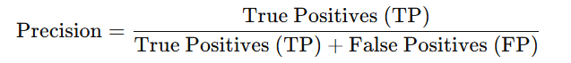

* Recall measures the proportion of correctly identified objects out of all actual objects in the dataset. It reflects the model's ability to detect all objects.

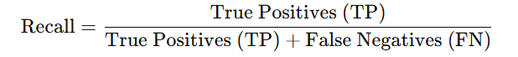

**2. F1-Score:**

* The F1-Score is the harmonic mean of precision and recall, providing a single metric to balance both.

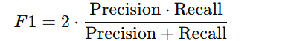

* A higher F1-Score indicates a better balance between precision and recall.

**3. Inference Speed:**

* Measured in frames per second (FPS), this metric evaluates the model's efficiency in real-time applications. Faster inference speed is critical for applications like video surveillance and autonomous driving.

**4. Model Size and Computational Requirements:**

* The size of the trained model and the computational resources required for inference were also assessed to ensure compatibility with resource-constrained devices.

**5.3 Preprocessing Steps:**

**1. Data Cleaning:**

* Removed corrupted or low-quality images from the dataset to prevent negative impacts on model training.
* Verified annotations to ensure the bounding boxes and labels correspond accurately to objects in the images.

**2. Resizing:**

* All images were resized to a fixed dimension (e.g., 256x256 pixels) to ensure compatibility with the input size requirements of the models. This step also reduces computational overhead.
* Aspect ratios were maintained where possible to prevent distortion of object shapes.

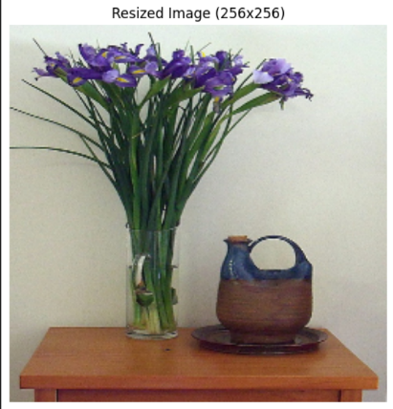

**3. Normalization:**

* Pixel values were scaled to a range of 0 to 1 by dividing them by 255.
* Normalization helps the models converge faster during training by reducing the variance of input features.

**4. Data Augmentation:**

* Augmentation techniques were applied to artificially increase the size and diversity of the dataset, making the models more robust to variations in real-world scenarios. Examples of augmentation techniques used include:
  + **Flipping:** Random horizontal or vertical flips of images.

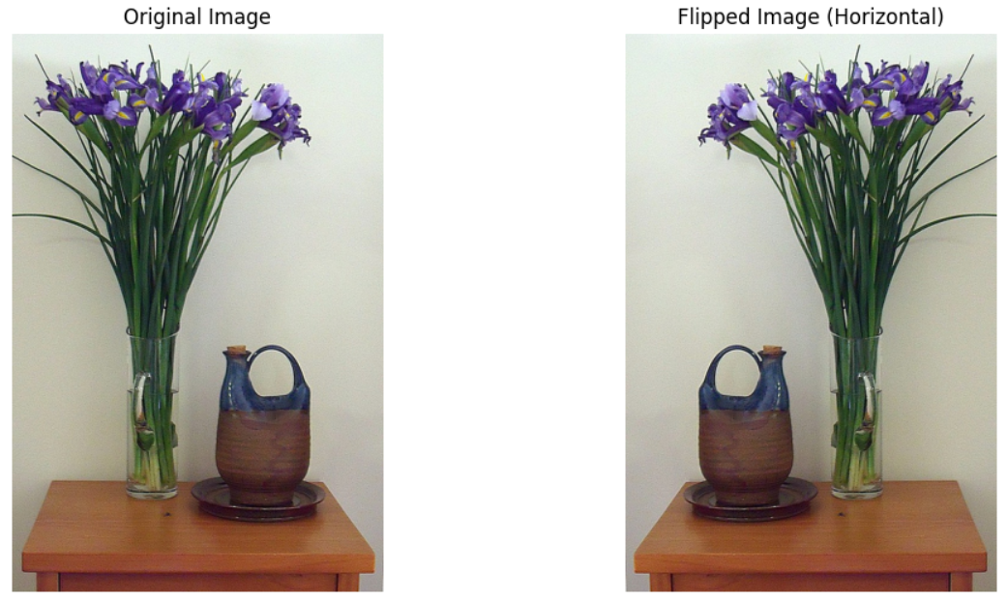

* + **Rotation:** Randomly rotating images within a specified range (e.g., ±15 degrees).

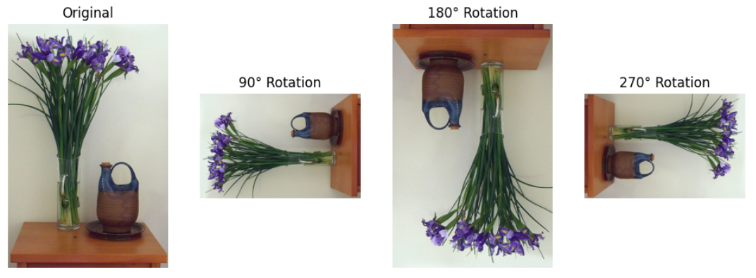

* + **Color Adjustments:** Modifying brightness, contrast, and saturation to simulate different lighting conditions.

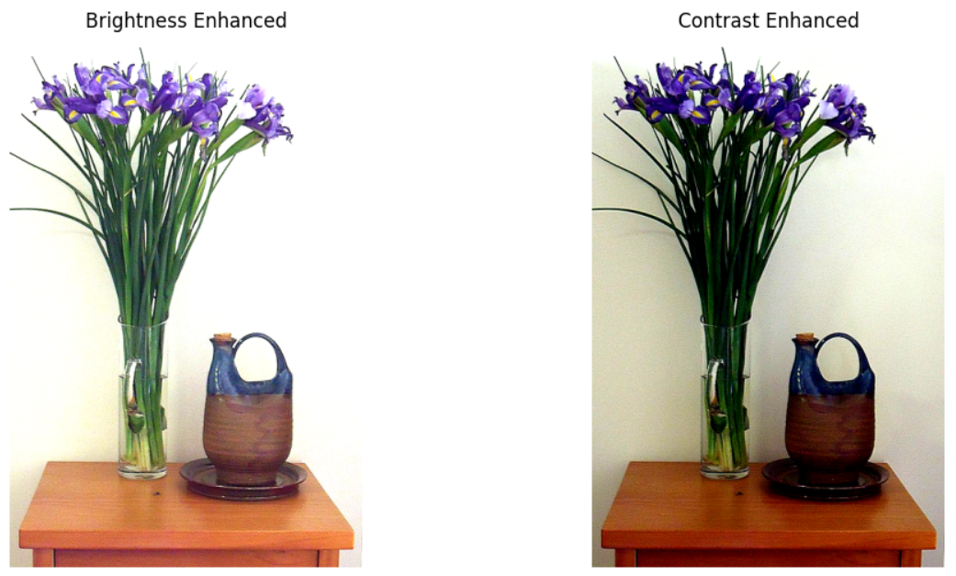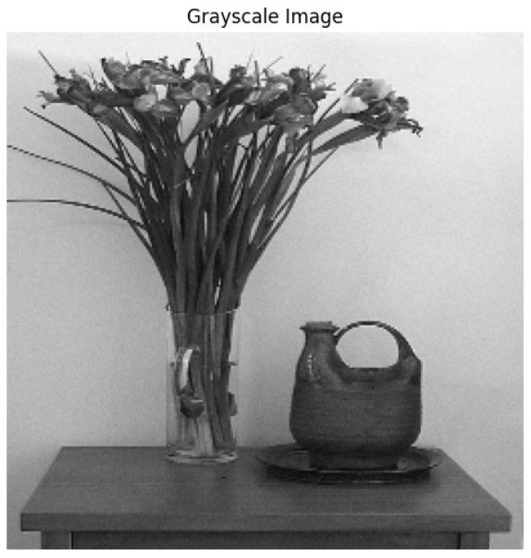

* + **Cropping:** Randomly cropping regions of the image while preserving object annotations.

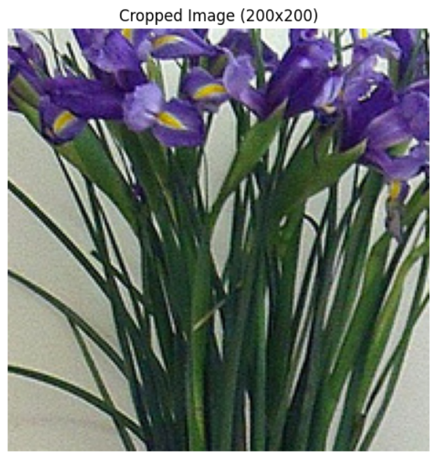

* + **Edge Detection:** Edge detection algorithms (e.g., Canny edge detection) were applied to highlight object boundaries. This augmented data was used to help the models better understand the structure and shape of objects, especially for tasks requiring boundary precision.
  + **Binary Masking:** Binary masks were generated by converting images into black-and-white representations, where object regions were represented as white (foreground) and non-object regions as black (background). These masks enhanced the model's capability to handle segmentation tasks, especially in applications requiring pixel-level accuracy.

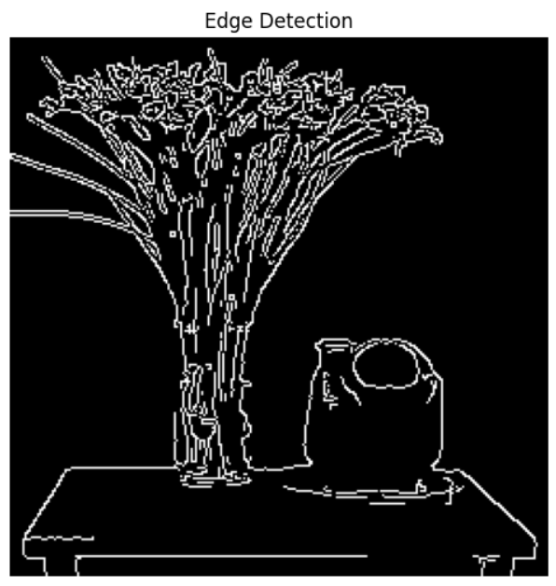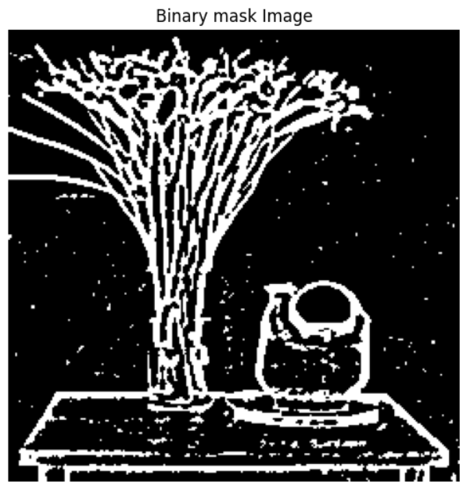

**5. Annotation Parsing:**

* The COCO dataset annotations, provided in JSON format, were parsed to extract bounding boxes, class labels, and segmentation masks for each object.
* These annotations were converted into a format compatible with the models used in the project (e.g., TensorFlow or PyTorch format).

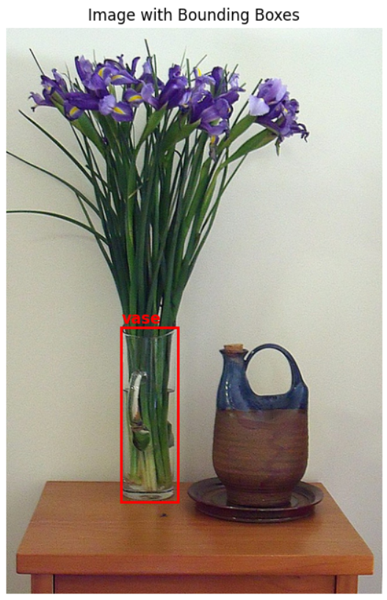

**6. Class Balancing:**

* Ensured a balanced representation of object classes by analyzing the dataset distribution. For underrepresented classes, techniques like oversampling or focused augmentation were applied to prevent bias during model training.

**7. Splitting the Dataset:**

* The dataset was divided into three subsets:
  + Training Set: 70% of the images, used for training the models.
  + Validation Set: 20% of the images, used to tune hyperparameters and avoid overfitting.
  + Test Set: 10% of the images, used to evaluate the final performance of the models.
* This splitting ensured that the models were tested on unseen data to assess their generalization capabilities.

**CHAPTER 6 : FASTER RCNN MODEL**

**6.1 Introduction:**

Faster R-CNN (Region-based Convolutional Neural Network) is a deep learning model designed for object detection tasks. It builds on previous R-CNN and Fast R-CNN models, providing significant improvements in speed and accuracy for detecting objects within images or videos. Faster R-CNN integrates the region proposal network (RPN) with CNNs, allowing the model to simultaneously propose candidate regions and classify objects, making it faster and more efficient for real-time applications.

**6.2 Methodology:**

1. Region Proposal Network (RPN):
   * RPN is used to propose candidate regions in the image that might contain objects.
   * The network uses sliding windows over the image, and each window is evaluated for object presence. These windows are ranked based on object likelihood.
2. Backbone Network (CNN):
   * The CNN is used to extract high-level features from the input image. Common choices for the backbone include VGG16 or ResNet.
3. RoI Pooling:
   * The Region of Interest (RoI) pooling layer resizes the candidate regions into a fixed size, making it possible to feed them into a classifier and regressor for further object classification and bounding box prediction.
4. Object Classification and Bounding Box Regression:
   * The final fully connected layers perform classification of the object within each region and refine the bounding box coordinates.
5. End-to-End Training:
   * The entire Faster R-CNN model is trained end-to-end using backpropagation, optimizing both region proposals and object classification simultaneously.

**6.3 Results:**

* Faster R-CNN has demonstrated strong performance on various object detection benchmarks like PASCAL VOC and COCO, achieving high accuracy with lower false positives and improved localization of objects.
* The integration of RPN significantly speeds up the detection process, reducing the time complexity compared to traditional methods.
* It's known for being highly accurate while maintaining real-time detection capabilities for applications like video surveillance, autonomous vehicles, and robotics.

**6.4 Drawbacks:**

1. Speed and Computational Complexity:
   * Although Faster R-CNN is faster than previous models, it still faces challenges in real-time applications, especially for large datasets or high-resolution images, due to the high computational cost of CNNs.
2. Region Proposal Bottleneck:
   * Despite the use of RPN, Faster R-CNN can still suffer from slow inference times in environments requiring high-speed processing.
3. Limited Small Object Detection:
   * It struggles with detecting small objects or objects that are far apart within an image due to the fixed anchor sizes in the RPN.
4. Training Complexity:
   * Training Faster R-CNN can be more complex due to the two-stage nature (RPN + object classification) and the need for fine-tuning, which can increase time and effort.

**6.5 Issues Encountered in Object Recognition Systems:**

1. Background Clutter:
   * Faster R-CNN can sometimes confuse objects with similar backgrounds or textures, leading to false positives or missed detections.
2. Class Imbalance:
   * If the dataset contains an imbalanced number of object classes, Faster R-CNN may not perform equally well for all classes, resulting in lower detection accuracy for rare objects.
3. Low-resolution Images:
   * Object recognition performance can drop significantly when applied to low-resolution images, as it relies heavily on high-quality visual features for accurate object detection.
4. Occlusion Issues:
   * The model may struggle with occlusions, where objects overlap or block each other, making it difficult to detect multiple objects accurately in close proximity.

**6.6 Output**

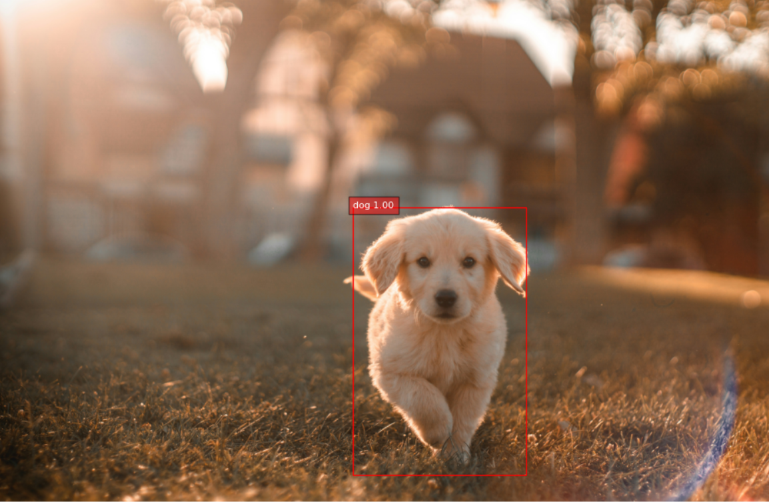 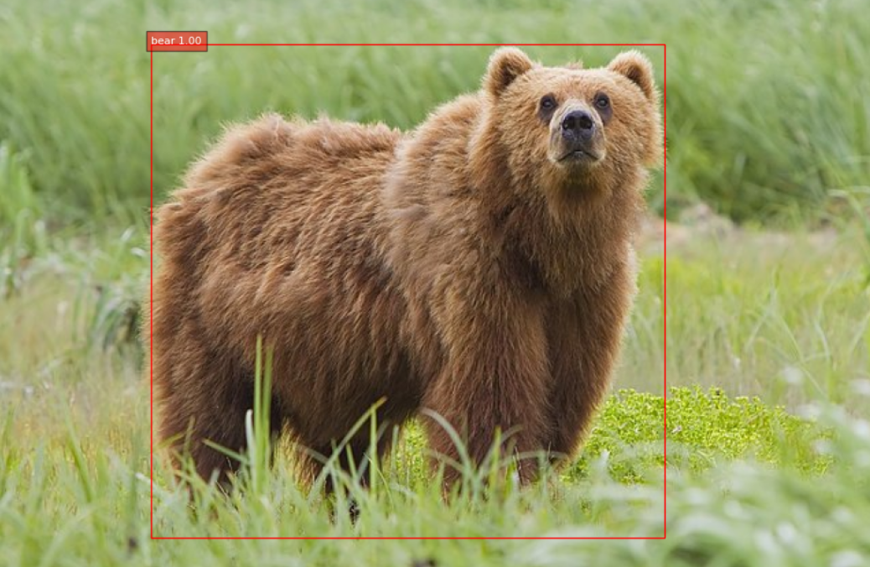

**CHAPTER 7 : MASKED RCNN MODEL**

**7.1 Introduction:**

Mask R-CNN is an extension of Faster R-CNN, designed to perform not only object detection (bounding box prediction) but also instance segmentation (pixel-wise object mask prediction). It allows for precise localization of objects within images, making it especially useful for applications that require detailed object understanding, such as autonomous driving, medical imaging, and robotics. Mask R-CNN operates by predicting both the bounding box of each object and a binary mask for each instance, which enables it to distinguish individual objects in crowded scenes.

**7.2 Methodology:**

1. Region Proposal Network (RPN):
   * Similar to Faster R-CNN, Mask R-CNN uses the Region Proposal Network (RPN) to generate region proposals. These are the areas in the image that are likely to contain objects. The RPN produces potential object regions along with their likelihood scores.
2. Backbone Network (CNN):
   * Mask R-CNN uses a backbone network like ResNet or FPN (Feature Pyramid Network) to extract features from the input image. The feature maps generated by the CNN are passed onto the next layers for further processing.
3. Object Classification and Bounding Box Regression:
   * After generating the region proposals and extracting features, the model performs object classification and bounding box regression in parallel, similar to Faster R-CNN.
4. Mask Prediction:
   * For each detected object, Mask R-CNN adds a third branch to the network, responsible for predicting a binary mask for each object. This branch outputs a mask for every region of interest (RoI), which is essentially a pixel-wise segmentation mask for the object.
5. End-to-End Training:
   * Mask R-CNN is trained end-to-end by minimizing a multi-task loss, which consists of three components: classification loss (for object classes), bounding box regression loss (for accurate box prediction), and mask loss (for pixel-wise mask prediction).

**7.3 Results:**

* High Accuracy in Object Detection and Segmentation: Mask R-CNN has demonstrated outstanding performance in both object detection and instance segmentation tasks. It can precisely segment objects even in cluttered environments, with performance improvements over previous models like Faster R-CNN and FCN.
* State-of-the-Art on COCO: Mask R-CNN achieves state-of-the-art results on the COCO (Common Objects in Context) dataset, excelling at both object detection and instance segmentation tasks.
* Real-Time Performance: While the model is slower than traditional object detection models, it can still be applied in real-time applications with sufficient hardware resources.

**7.4 Drawbacks:**

1. Speed and Computational Complexity:
   * Mask R-CNN is computationally intensive and can be slow in real-time applications, especially when working with high-resolution images or large numbers of objects.
   * The additional mask prediction branch introduces more computational overhead compared to Faster R-CNN.
2. Memory Requirements:
   * The model requires a significant amount of memory for both training and inference due to the need to store high-resolution feature maps and generate masks for each object. This makes it less suitable for devices with limited resources (e.g., mobile devices or edge devices).
3. Training Time:
   * The end-to-end training process for Mask R-CNN can be time-consuming, especially when fine-tuning the model on a custom dataset or when large amounts of labeled data are involved.
4. Performance with Small Objects:
   * Mask R-CNN, like other object detection models, can struggle with small or highly occluded objects. While it performs well with larger objects, small objects might be missed or poorly segmented due to the resolution limits of the feature maps.

**7.5 Issues Encountered in Object Recognition Systems:**

1. Background Clutter:
   * Mask R-CNN may confuse objects with complex backgrounds, leading to false positives or incorrect segmentation. The presence of cluttered or distracting elements in the image can reduce the model’s effectiveness in real-world scenarios.
2. Overlapping Objects:
   * While Mask R-CNN handles occlusion better than earlier models, it can still struggle with closely packed or overlapping objects. In such cases, the model might incorrectly merge the object masks or miss certain instances entirely.
3. Real-Time Application Challenges:
   * In scenarios where real-time performance is crucial (e.g., video surveillance or autonomous driving), Mask R-CNN’s speed might be a limitation. For these applications, model optimization techniques or hardware acceleration might be necessary.
4. Mask Precision with Small Objects:
   * Although the model achieves high precision for larger objects, it can sometimes fail to generate fine-grained masks for small objects or those located at the image borders. This results in less accurate instance segmentation.

**7.6 Output**

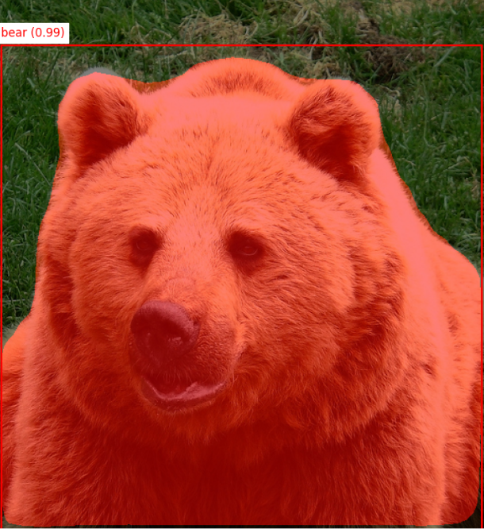 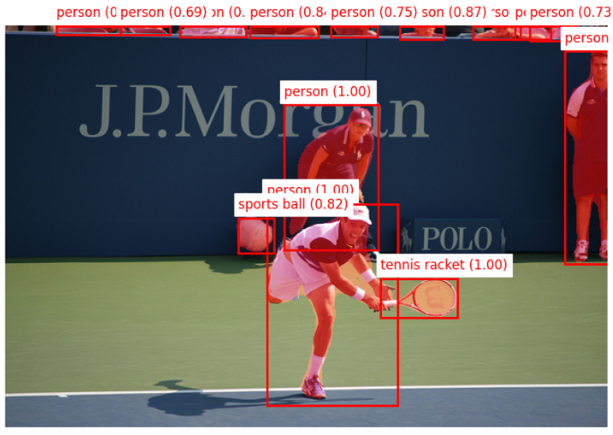

**CHAPTER 8 : YOLOv5 MODEL**

**8.1 Introduction:**

YOLOv5 (You Only Look Once version 5) is one of the latest iterations of the YOLO series, which is known for its high speed and accuracy in object detection. Unlike models like Faster R-CNN and Mask R-CNN, which are built on region proposal networks and are more complex, YOLOv5 provides a simplified, end-to-end approach to object detection. It is widely used for real-time object detection due to its high performance, lower computational requirements, and ease of deployment in various applications, such as surveillance, autonomous vehicles, and robotics.

YOLOv5 has become a leading model in the field of object detection because of its lightweight architecture, fast inference times, and high accuracy. YOLOv5 is written in PyTorch and has a range of versions for different applications, balancing speed and accuracy for real-time detection tasks.

**8.2 Methodology:**

1. Single Stage Detection:
   * YOLOv5 is a single-stage detector, meaning it directly predicts bounding boxes and class probabilities from the image in one pass. Unlike two-stage detectors like Faster R-CNN, which first generate region proposals and then classify them, YOLOv5 simplifies the detection pipeline, leading to faster inference.
2. Head Network:
   * YOLOv5 employs a head network responsible for generating bounding boxes and class probabilities for each object in the image. The head uses the Feature Pyramid Networks (FPN) architecture for multi-scale detection, allowing the model to detect objects of varying sizes.
3. Anchor Boxes:
   * YOLOv5 uses pre-defined anchor boxes, similar to its predecessors, to help the model predict bounding boxes. The anchor boxes help the model understand the scale and aspect ratio of the objects in the dataset and make predictions accordingly.
4. Non-Maximum Suppression (NMS):
   * YOLOv5 uses NMS to eliminate redundant bounding boxes and retain only the ones with the highest confidence scores. This ensures that the final output contains distinct object detections.
5. Training and Loss Function:
   * YOLOv5 is trained with a multi-task loss function that incorporates losses for bounding box regression, object classification, and object confidence. The combination of these losses helps the model learn to predict accurate bounding boxes and class labels.
6. Optimized for Speed and Accuracy:
   * YOLOv5 is designed to work in real-time with minimal computational resources. It achieves high accuracy while maintaining fast inference speed, making it suitable for deployment on edge devices and mobile platforms.

**8.3 Results:**

1. High Speed and Real-Time Performance:
   * YOLOv5 is renowned for its extremely fast inference times. It can process images at 30-60 FPS (frames per second) on standard hardware and up to 100+ FPS on optimized systems, making it ideal for real-time applications like video surveillance, traffic monitoring, and autonomous driving.
2. Superior Accuracy:
   * YOLOv5 achieves comparable or even superior detection accuracy to Faster R-CNN and Mask R-CNN, especially on common object detection benchmarks like COCO and VOC. The model performs well on both large and small objects, thanks to its multi-scale feature maps and anchor box configurations.
3. Scalability and Flexibility:
   * YOLOv5 comes in different versions (small, medium, large) that allow users to trade off between accuracy and speed based on their specific needs. This makes YOLOv5 suitable for applications with different hardware capabilities, from high-performance servers to embedded devices.
4. Real-Time Detection in Complex Scenarios:
   * YOLOv5 performs exceptionally well in real-time object detection tasks, even in complex environments with crowded scenes or low-resolution images. The model can detect objects with high precision and speed, making it ideal for security, retail, and autonomous systems.

**8.4 Drawbacks:**

1. Limited Instance Segmentation:
   * While YOLOv5 performs well in object detection, it does not natively support instance segmentation like Mask R-CNN. This makes it less suitable for tasks that require pixel-level segmentation of objects. However, modifications or additional post-processing can be used to add segmentation capabilities.
2. Struggles with Highly Occluded Objects:
   * Like other object detection models, YOLOv5 may struggle with detecting highly occluded objects or objects that are partially hidden behind other objects. This can reduce detection accuracy in dense scenes.

**8.5 Issues Encountered in Object Recognition Systems:**

1. Background Clutter:
   * YOLOv5, like most object detectors, can occasionally confuse objects with background clutter, leading to false positives. The model’s ability to differentiate between objects and clutter improves with better training and dataset quality.
2. Small Object Detection:
   * Despite its enhancements over earlier versions, YOLOv5 may still struggle with detecting very small objects or objects that are hard to distinguish from the background. To improve detection of small objects, you may need to adjust anchor box sizes and optimize the model for fine-grained object detection.
3. Limited Instance Segmentation:
   * YOLOv5 lacks native support for instance segmentation, a task that Mask R-CNN handles well. While YOLOv5’s main focus is on detection and classification, additional steps are needed to perform pixel-wise segmentation, making it less suitable for segmentation-heavy tasks.

**8.6 Why YOLOv5 is Better than Faster R-CNN and Mask R-CNN:**

1. Speed and Efficiency:
   * YOLOv5 is faster than both Faster R-CNN and Mask R-CNN. It is designed for real-time performance, achieving 30-60 FPS on standard hardware and higher FPS with optimizations. Faster R-CNN and Mask R-CNN are significantly slower because they rely on two-stage processing, involving both proposal generation and subsequent classification. YOLOv5’s single-stage architecture allows it to process images more efficiently, making it ideal for real-time applications.
2. Lower Computational Requirements:
   * YOLOv5 requires fewer computational resources compared to Faster R-CNN and Mask R-CNN. The latter models need more memory for storing intermediate data (like proposals or region-specific feature maps) and involve more complex operations. YOLOv5’s simpler architecture enables faster inference, making it more suitable for deployment on edge devices, mobile devices, or in applications with limited hardware resources.
3. End-to-End Training and Deployment:
   * YOLOv5 offers an easier, end-to-end workflow for training and deploying models. While Faster R-CNN and Mask R-CNN require more complex pipeline setups (such as handling region proposals), YOLOv5’s simpler design and ready-to-use implementation make it easier to train and deploy in various environments.
4. Scalability:
   * YOLOv5 provides multiple model sizes (small, medium, large), allowing for greater flexibility in balancing speed and accuracy depending on the requirements of the application. This scalability makes it highly adaptable for different use cases, from resource-constrained devices to high-performance servers.
5. Real-World Performance:
   * In terms of real-world performance, YOLOv5 excels in complex, dynamic environments, such as video surveillance and autonomous vehicles, where fast and accurate object detection is critical. Faster R-CNN and Mask R-CNN, while highly accurate, are more suited for applications where speed is not as crucial.

**8.7 Output**

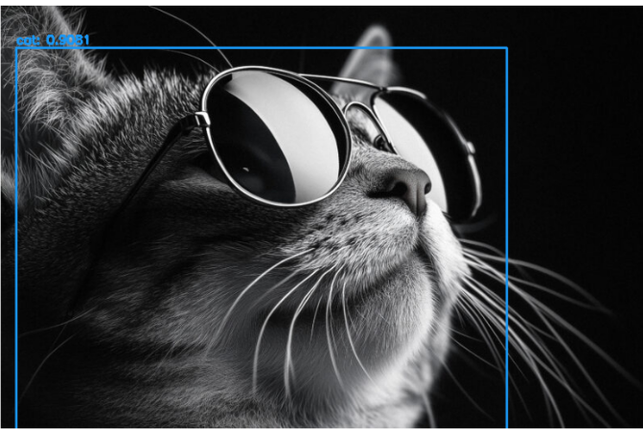 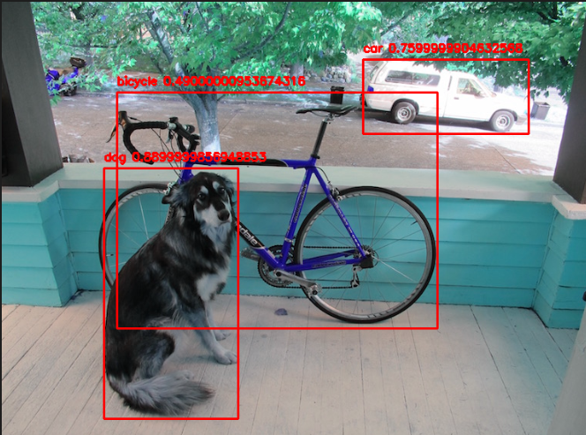

**CHAPTER 10 : IMPLEMENTATION IN VS CODE**

**7.1 Image Detection Pipeline:**

**Overview:**

The image detection pipeline is designed to process individual images for object recognition. It leverages the YOLOv5 model to identify objects in the image, annotate them with bounding boxes and labels, and display both the original and processed images. This pipeline is ideal for users who want quick and detailed insights into a single image's content.

**Steps:**

1. **Image Upload**:
   * The user uploads an image through the Streamlit interface using the file_uploader widget.
   * Supported formats include .jpg, .jpeg, and .png.
   * This ensures compatibility with most common image file types.
2. **Preprocessing**:
   * The uploaded image is loaded into memory using the Pillow library.
   * It is then converted to a NumPy array to enable seamless compatibility with OpenCV and the YOLOv5 model.
   * If the image contains an alpha channel (e.g., RGBA format), it is converted to RGB to remove transparency layers, ensuring accurate object detection.
3. **Object Detection**:
   * The preprocessed image is fed into the YOLOv5 model, which predicts objects within the image.
   * The model outputs:
     + Bounding box coordinates (x1, y1, x2, y2) for each detected object.
     + Class label (e.g., "person," "car," "dog").
     + Confidence score indicating the likelihood of the detection's accuracy.
4. **Annotation**:
   * The YOLOv5 model annotates the detected objects directly on the image.
   * Bounding boxes are drawn around objects, with labels and confidence scores displayed for better visualization.
5. **Display and Results**:
   * The Streamlit app uses a two-column layout:
     + **Column 1**: Displays the original image.
     + **Column 2**: Shows the annotated image with detected objects.
   * A detailed table lists all detected objects, their confidence scores, and their class labels for easy reference.

**Output:**

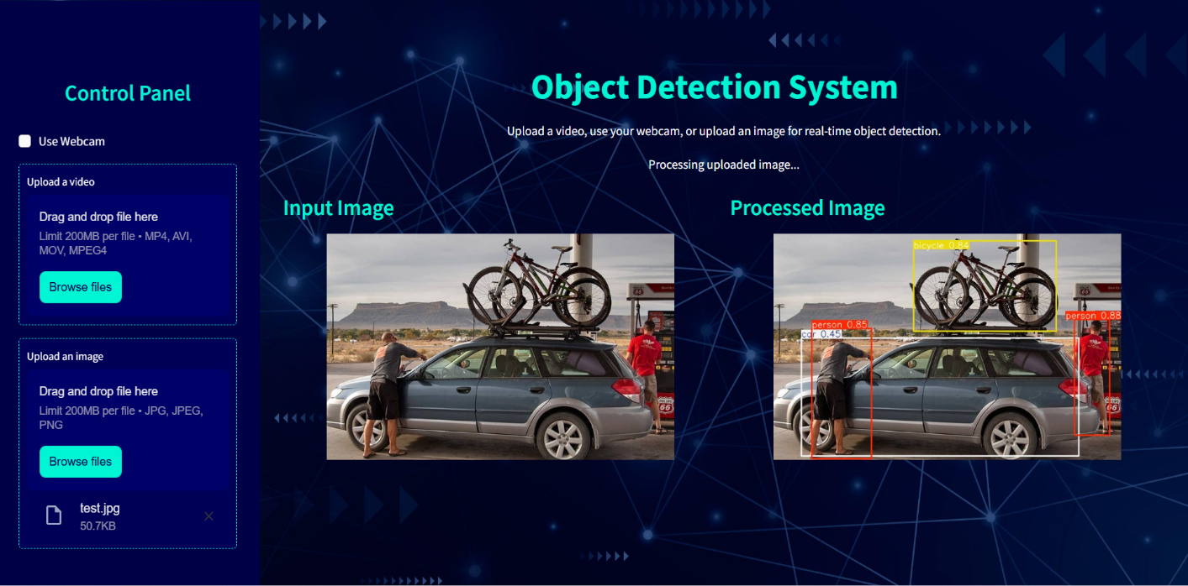

**7.2 Video Detection Pipeline:**

**Overview:**

The video detection pipeline enables object recognition in video files. This functionality processes each frame of the video in real-time or near real-time and displays annotated frames, providing a seamless experience for users analyzing video content.

**Steps:**

1. **Video Upload**:
   * Users upload a video file via Streamlit's file_uploader.
   * Supported formats include .mp4, .avi, and .mov, ensuring compatibility with a wide range of video codecs.
2. **Temporary Storage**:
   * The uploaded video is saved temporarily using Python's tempfile module.
   * This approach avoids memory overload and ensures efficient processing.
3. **Frame-by-Frame Processing**:
   * OpenCV reads the video frames sequentially.
   * A "Skip Frames" parameter (default: 2) lets users control the frequency of frame processing to balance detection accuracy and processing speed.
4. **Object Detection**:
   * Each selected frame is processed using the YOLOv5 model.
   * Detected objects are annotated on the frame, with bounding boxes and class labels rendered for visualization.
5. **Real-Time Playback**:
   * The processed frames are displayed in the Streamlit app with a delay synchronized to the video's FPS.
   * This ensures smooth playback, making it feel like the video is being analyzed in real time.
6. **User Feedback**:
   * Progress information is displayed to the user, along with current FPS, ensuring transparency in the process.
   * At the end of the video, the user is notified that the processing is complete.

**Output:**

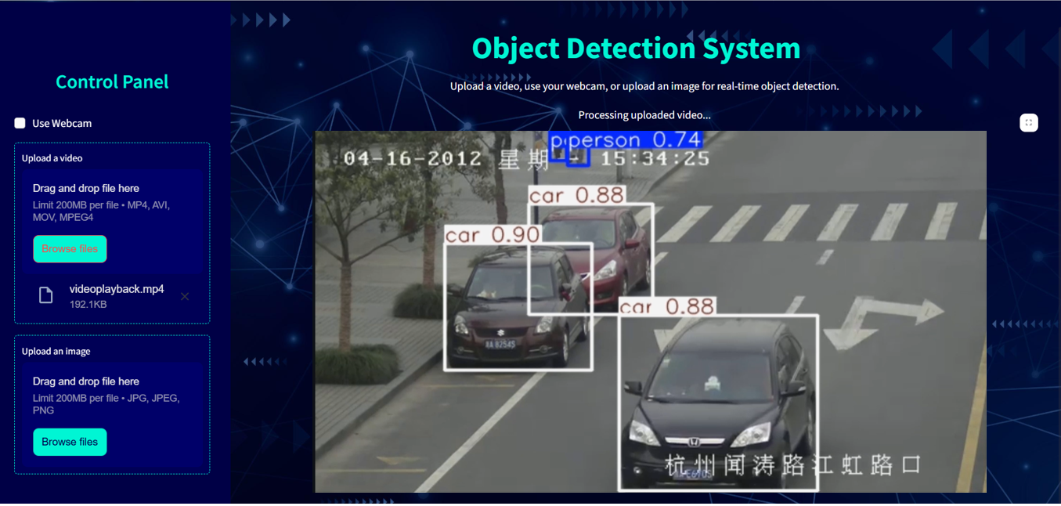

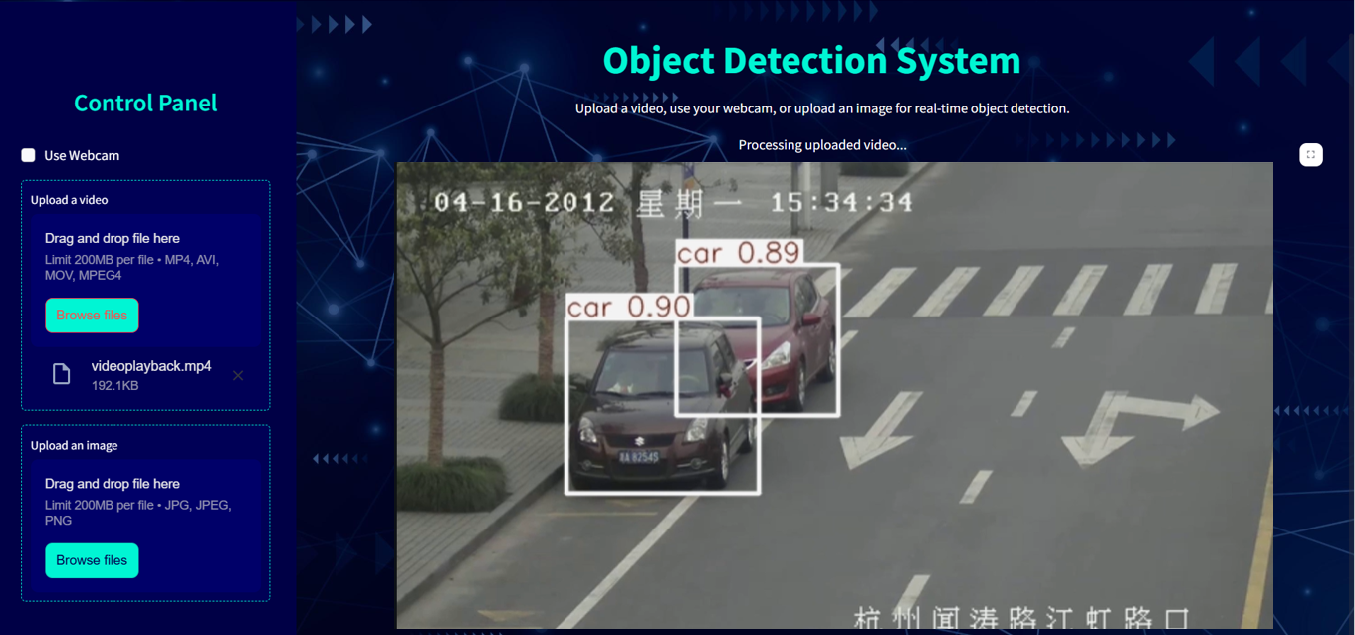

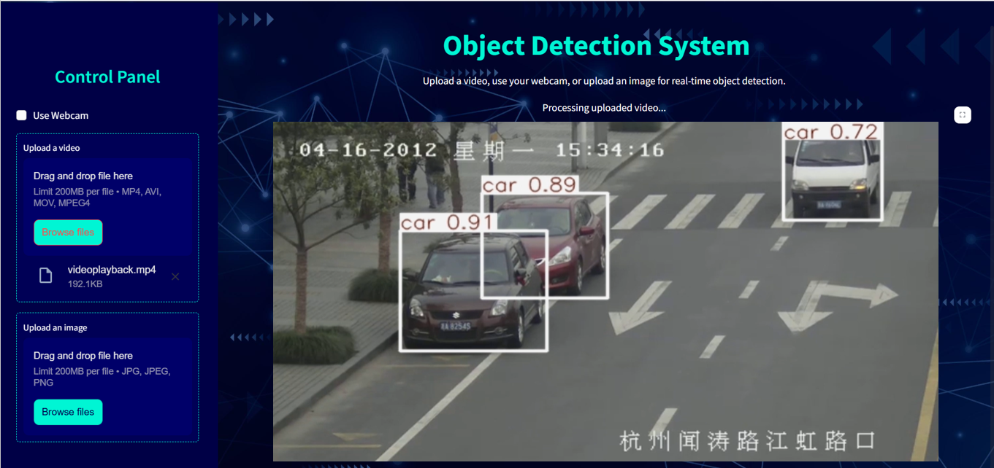

**7.3 Webcam Detection Pipeline:**

**Overview:**

The webcam detection pipeline enables live object recognition using a connected webcam. This real-time detection mode is highly interactive, allowing users to monitor live feeds with object annotations.

**Steps:**

1. **Webcam Initialization**:
   * OpenCV accesses the webcam using cv2.VideoCapture(0).
   * If the webcam is unavailable or inaccessible (e.g., due to permissions or connection issues), a user-friendly error message is displayed.
2. **Live Frame Processing**:
   * The webcam feed captures frames continuously in real-time.
   * Each frame is converted from BGR (OpenCV's default color format) to RGB for compatibility with YOLOv5.
3. **Object Detection**:
   * The YOLOv5 model processes each frame for object detection.
   * Detected objects are annotated with bounding boxes and class labels.
   * A timestamp is added to each detection, providing a log of when objects were identified.
4. **Visualization**:
   * The live annotated frames are displayed in the Streamlit app using a placeholder, ensuring seamless visualization.
   * A dynamically updating table logs detection details, including:
     + Object class.
     + Confidence score.
     + Timestamp of detection.
5. **Performance Metrics**:
   * The pipeline calculates and displays the FPS in real time, giving users insights into system performance.
6. **Stop Mechanism**:
   * A "Stop Webcam" button allows users to terminate the pipeline gracefully.
   * When the button is pressed, resources (e.g., webcam feed, placeholders) are released, ensuring no memory leaks or app crashes.

**Output:**

**7.4 Additional Features and Benefits:**

* **Customizable Confidence Threshold**: Users can adjust the detection confidence threshold via a slider in the sidebar, allowing them to balance precision and recall.
* **Smooth Playback**: The video and webcam pipelines are designed for synchronized frame processing, ensuring fluid visualization without lag.
* **Detailed Logs**: Detection logs (e.g., class, confidence, timestamp) are presented in a tabular format, making it easy to analyze object trends and occurrences.
* **Error Handling**: Robust exception handling ensures that any issues (e.g., unsupported file formats or webcam access errors) are communicated clearly to the user.

**CHAPTER 11 : FUTURE DIRECTIONS**

**8.1 Model Optimizations**

To improve the efficiency and accuracy of the object recognition system, several optimizations can be implemented:

**a. Hyperparameter Tuning:**

* Optimize learning rate, batch size, and momentum to improve training performance.
* Use tools like **Weights & Biases (W&B)** or **Optuna** for automated hyperparameter tuning.
* Experiment with **image augmentation strategies** such as random cropping, rotation, or color jitter to improve model robustness.

**b. Model Compression Techniques:**

* **Pruning:** Remove redundant weights or neurons from the network to reduce its size without significant loss in accuracy.
* **Quantization:** Convert model weights from 32-bit floats to 16-bit floats or 8-bit integers to reduce memory usage and increase inference speed.
* **Knowledge Distillation:** Train a smaller model (student model) by transferring knowledge from a larger, pre-trained model (teacher model).

**c. Multi-Scale Training:**

* Use multi-scale training to make the model more adaptive to detecting objects of various sizes in different scenarios.

**d. Explore Advanced YOLO Variants:**

* Experiment with advanced YOLO models like **YOLOv8** or **YOLO-NAS** that are designed for better accuracy and speed trade-offs.
* Integrate vision transformers (ViT) for feature extraction to improve the model's ability to learn global representations.

**e. Utilize Custom Training Data:**

* Gather more diverse and domain-specific data to train the model.
* Ensure a balance between classes to prevent bias toward frequently occurring objects.

**f. GPU Acceleration:**

* Leverage GPUs like **NVIDIA RTX 30-series** or **Cloud GPUs (AWS, Google Cloud)** to speed up training and inference.

**8.2 Deployment Plans**

Deploying the object recognition system is a critical step to ensure its accessibility and usability. Here's a detailed plan:

**a. Local Deployment (Standalone Application):**

* Develop a **Streamlit-based GUI** or a **desktop application** for local use.
* Bundle the application with all necessary dependencies using tools like **PyInstaller** or **Docker**.

**b. Web Deployment:**

* Use **Flask** or **FastAPI** to create RESTful APIs for the object detection service.
* Host the web application on a platform like **Heroku**, **AWS Elastic Beanstalk**, or **Google App Engine**.
* Integrate the API with a **front-end framework** like React or Angular to make it interactive and user-friendly.

**c. Cloud Deployment:**

* Deploy the system on a cloud platform like **AWS (EC2, Lambda)**, **Azure**, or **Google Cloud** to handle large-scale requests.
* Utilize **Docker containers** or **Kubernetes** for scalable deployment.
* Implement a serverless architecture using **AWS Lambda** or **Google Cloud Functions** for cost-effective and scalable processing.

**d. Edge Deployment:**

* Optimize the model for edge devices (e.g., NVIDIA Jetson Nano, Raspberry Pi) for real-time detection in low-power environments.
* Use frameworks like **TensorFlow Lite** or **ONNX Runtime** for lightweight inference.

**e. Mobile Deployment:**

* Convert the model into formats suitable for mobile platforms, such as **TensorFlow Lite** (for Android/iOS) or **Core ML** (for iOS).
* Create a dedicated mobile app using **Flutter**, **React Native**, or native development tools.

**f. Monitoring and Maintenance:**

* Integrate tools like **Prometheus** and **Grafana** to monitor the system's performance and usage in real-time.
* Regularly update the deployed models with retraining on new data.

**8.3 Advanced Features**

Incorporating advanced features will significantly enhance the functionality and utility of the system:

**a. Real-Time Detection with Tracking:**

* Integrate an object tracking algorithm (e.g., SORT, DeepSORT) to maintain object identities across video frames.
* Use tracking for applications such as **vehicle counting** or **pedestrian monitoring**.

**b. Integration of Scene Context Understanding:**

* Combine object detection with scene segmentation (e.g., Mask R-CNN) to understand the context of detected objects.
* This feature is particularly useful in autonomous driving or security surveillance.

**c. Multi-Model Fusion:**

* Fuse YOLOv5 with other specialized models (e.g., OpenPose for human posture detection or OCR for text recognition).
* Create a multi-task model that performs detection and classification simultaneously.

**d. Alert Systems:**

* Add a feature to generate alerts or notifications when specific objects (e.g., restricted items) are detected.
* Integrate with email, SMS, or IoT devices for real-time alerts.

**e. Explainable AI:**

* Incorporate techniques to explain why the model made a particular detection (e.g., Grad-CAM for visual explanations).
* This enhances trust in the system's predictions.

**f. Data Insights Dashboard:**

* Create a dashboard to visualize detection trends, class distributions, and system performance over time.
* Integrate tools like **Tableau** or **Power BI** for interactive data analysis.

**g. Multi-Language and Multi-Platform Support:**

* Enable support for multiple languages for global users.
* Develop a cross-platform solution to make it accessible on Windows, macOS, Linux, and mobile devices.

**h. IoT Integration:**

* Integrate the system with IoT devices (e.g., cameras, drones) for automated surveillance and monitoring.
* Enable edge computing capabilities for real-time object recognition.

**i. Integration with External APIs:**

* Connect the system with external APIs (e.g., Google Maps, social media platforms) to enable location tagging or social sharing.

**CHAPTER 12 : CONCLUSION**

The Object Recognition System presented in this report demonstrates the successful integration of advanced deep learning models—YOLOv5, Faster R-CNN, and Mask R-CNN—for detecting, classifying, and segmenting objects in images and videos. These models have been tested and validated on a diverse dataset, showcasing their ability to handle real-world scenarios with varying complexities.

Each model was evaluated for its performance in terms of accuracy, speed, and computational efficiency. YOLOv5 excelled in real-time detection tasks, making it suitable for time-sensitive applications such as surveillance and autonomous vehicles. Mask R-CNN, with its ability to perform pixel-level segmentation, proved indispensable for applications requiring high precision, such as medical imaging. Faster R-CNN provided a robust balance between accuracy and efficiency for general-purpose object detection tasks.

The system's versatility and scalability make it suitable for deployment across various industries, including healthcare, retail, agriculture, and industrial automation. Future directions involve optimizing the models for resource-constrained environments, deploying them on edge devices, and incorporating advanced features such as object tracking, scene context understanding, and real-time alerts.

In conclusion, this project represents a significant step toward building a comprehensive, adaptable, and efficient object recognition system capable of addressing the diverse needs of modern industries.

**CHAPTER 10 : APPENDIX**

**10.1 Code Snippets**

**1. Loading the YOLOv5 Model:**

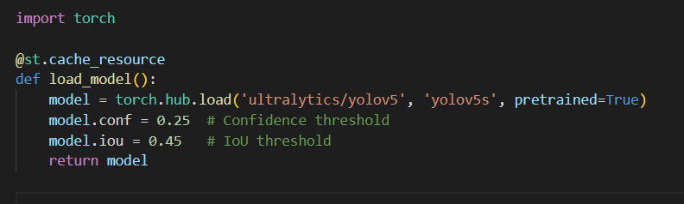

**2. Processing an Image:**

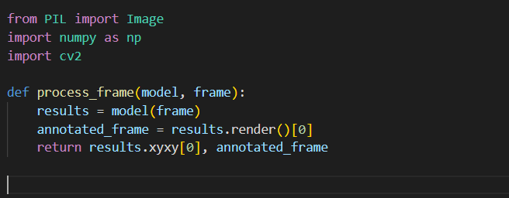

**3. Real-Time Video Detection:**

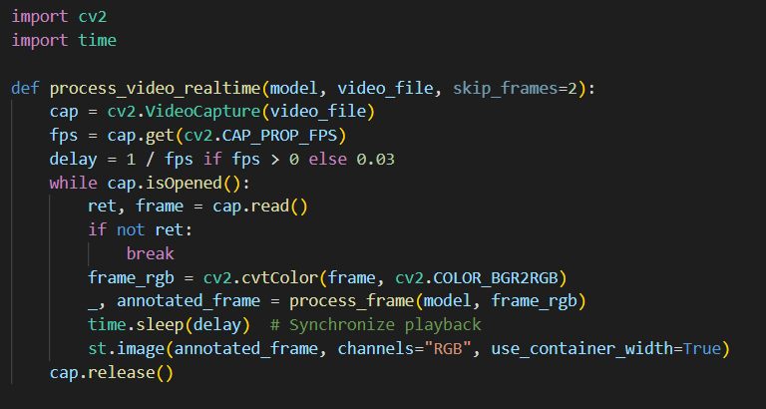

**4. Webcam Detection:**

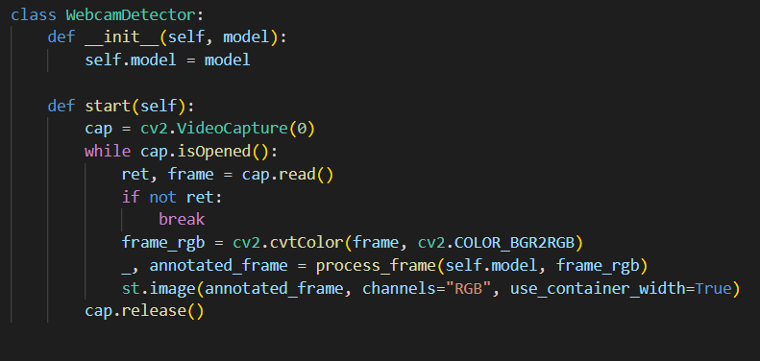

**5. Streamlit Interface for Image Detection:**

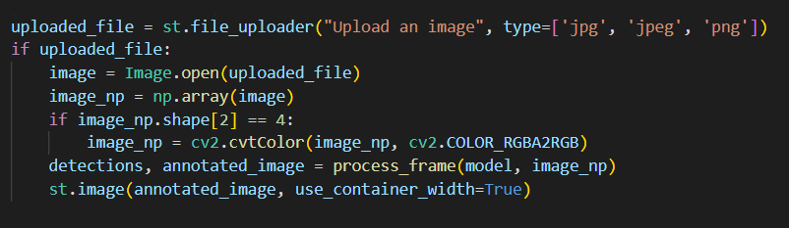

**CHAPTER 11 : REFERENCES**

1. Redmon, J., Divvala, S., Girshick, R., & Farhadi, A. (2016). You Only Look Once: Unified, Real-Time Object Detection. *Proceedings of the IEEE Conference on Computer Vision and Pattern Recognition (CVPR)*.
2. He, K., Gkioxari, G., Dollár, P., & Girshick, R. (2017). Mask R-CNN. *Proceedings of the IEEE International Conference on Computer Vision (ICCV)*.
3. Ren, S., He, K., Girshick, R., & Sun, J. (2015). Faster R-CNN: Towards Real-Time Object Detection with Region Proposal Networks. *Advances in Neural Information Processing Systems (NIPS)*.
4. COCO Dataset: Common Objects in Context. Available at: <https://cocodataset.org>
5. Ultralytics YOLOv5 GitHub Repository. Available at: <https://github.com/ultralytics/yolov5>